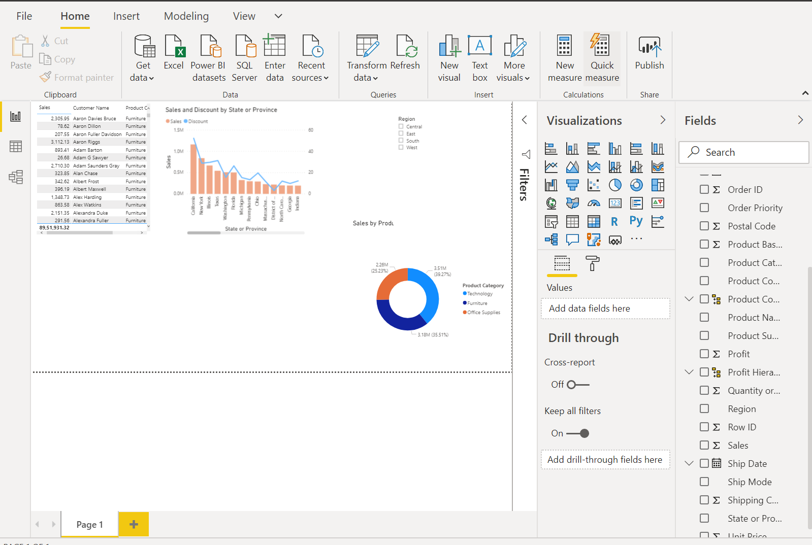

1.Overall Dashboard

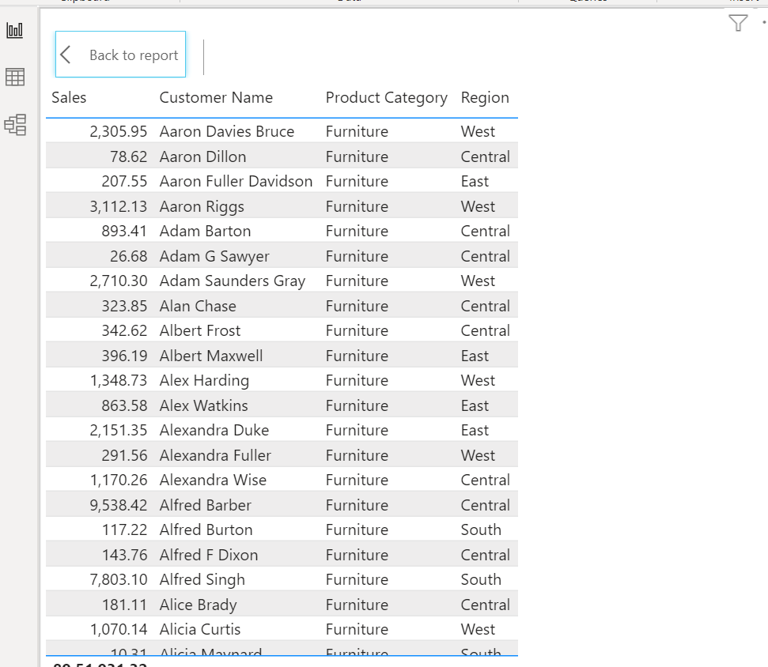 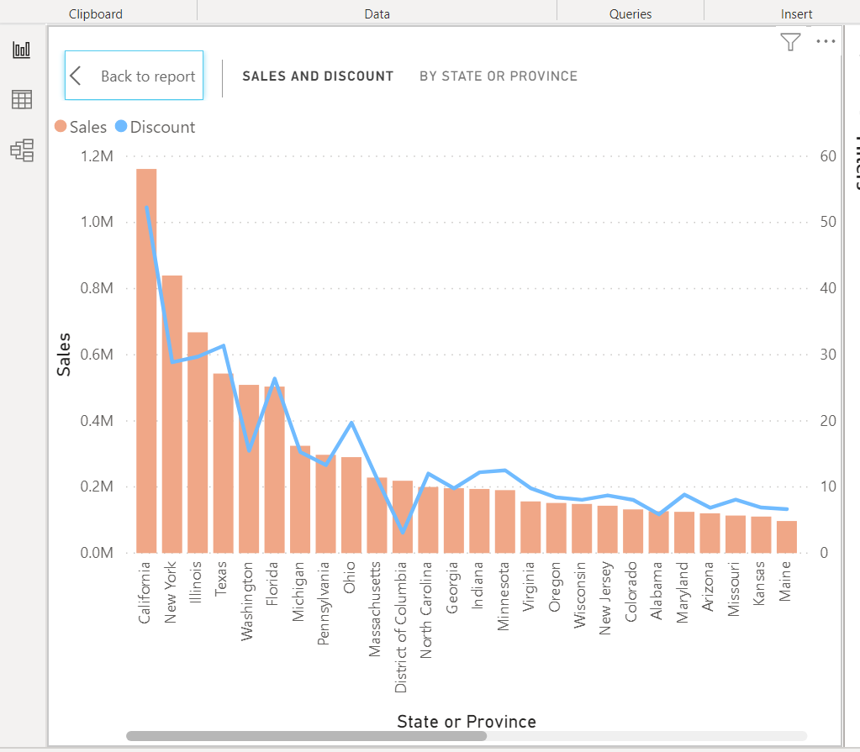

2. Sales by Customer, Product and Region 3. Sales and Discount w.r.t States and Provinces

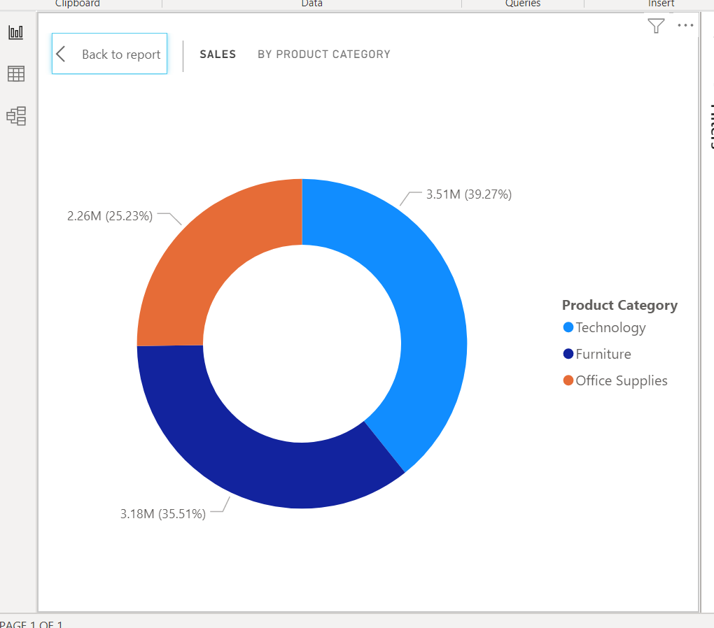 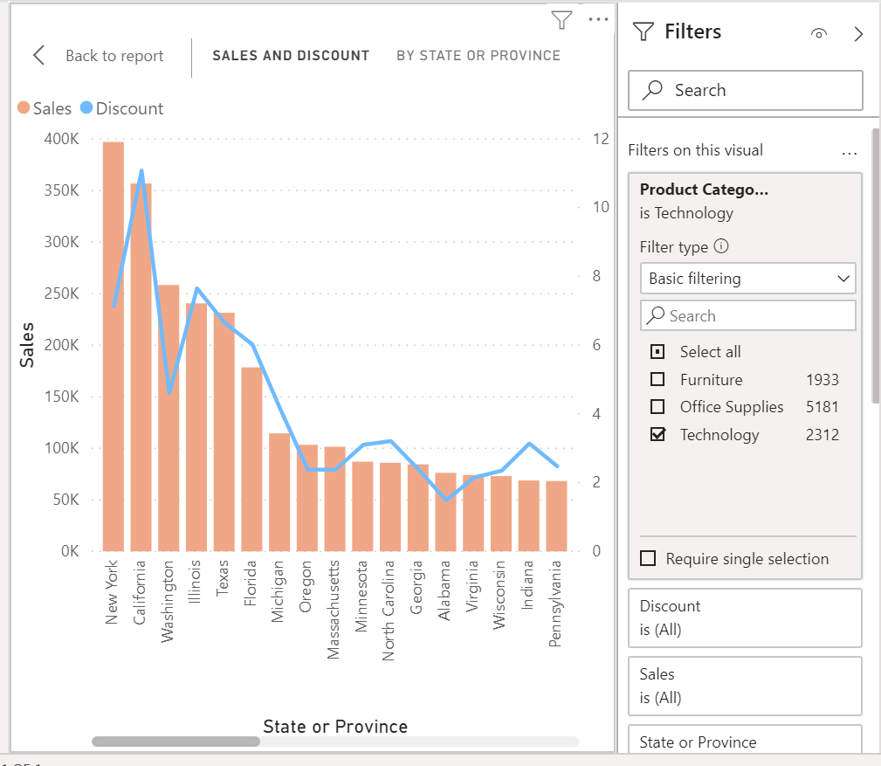

4. Sales by Category 5. Answer: NewYork has highest Sales in Technology